On click of Access advanced Features

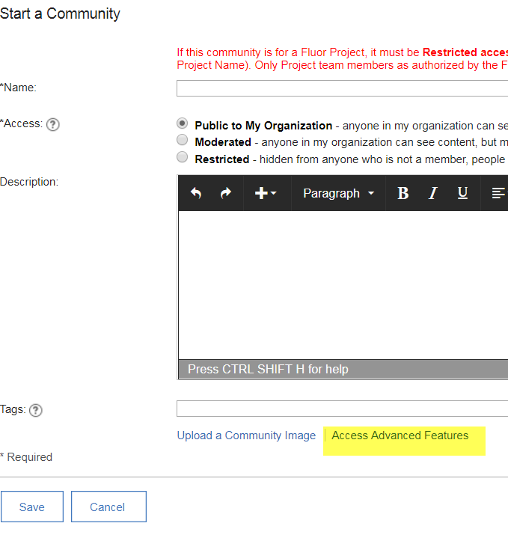

Above member add the following field **Community Manager** (Person field) above field add guidance text “Select the person who will be responsible for the content and maintenance of the community – This person must also be added as an Owner”

